**NANDHA ENGINEERING COLLEGE**

**(Autonomous Institution)**

Erode-638 052



**TABLEAU-TWO CREDIT COURSE**

**IV – Semester**

**B.Tech - Artificial Intelligence and Data Science**

**NAME : Naresh B A**

**BRANCH : B. TECH AI & DS**

**YEAR : II**

**What is Tableau?**

**Tableau** is a powerful **data visualization and business intelligence (BI) tool**.  
It helps people **connect to data**, **analyze it**, and **create beautiful dashboards, charts, and reports** — all without needing to write complex code.

**Why is Tableau Used?**

* To **quickly explore** big sets of data
* To **turn numbers into visual stories** (maps, graphs, pie charts, etc.)
* To **spot trends, patterns, and insights** easily
* To **share** interactive dashboards with others (teams, managers, public)

Key Features

* Drag-and-drop interface (easy to use)
* Connects to many data sources (Excel, SQL, Google Sheets, etc.)
* Real-time data updates
* Interactive dashboards
* Can handle **large datasets** smoothly
* Allows creating **stories** (like a slideshow of insights)

**Overview of Netflix Dashboard**

The **Netflix Dashboard** is designed to explore and analyze Netflix’s Movies and TV Shows.  
It covers key insights like:

* Number of shows and movies added over the years
* Distribution of content by country
* Ratings breakdown (e.g., TV-MA, PG-13)
* Popular genres
* The difference between Movies and TV Shows

**Total Movie & TV Show by years**

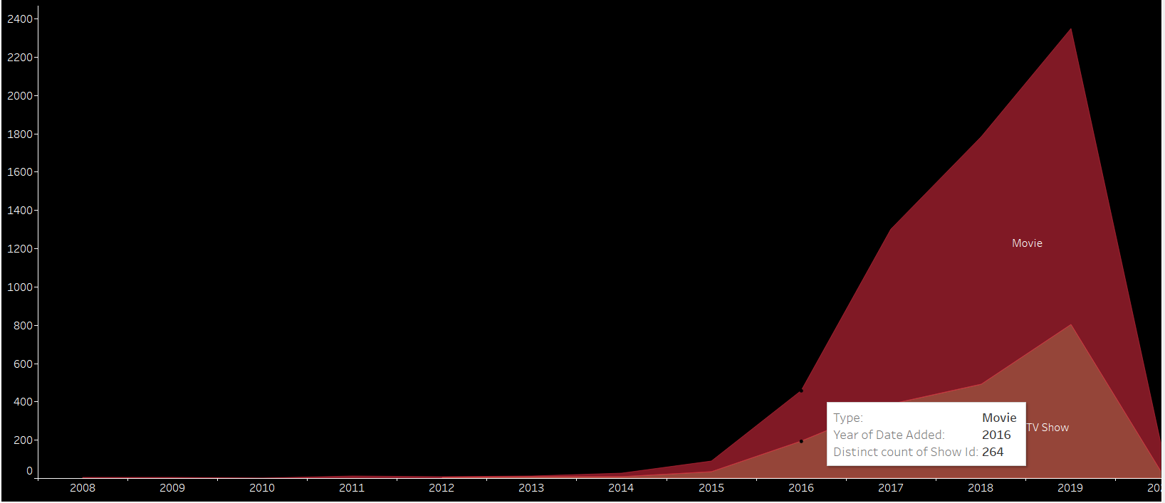

• Before **2015**, almost no content was added.

• In **2016**, there was a **big rise** — around 264 Movies added (as shown by the tooltip).

• **Movies** grew **much faster** than TV Shows.

• Peak in **2019**, with the **highest number** of content added.

• After 2019, the number **dropped** (sharp decline in 2020).

Total Movies & TV Show by Country need a explain

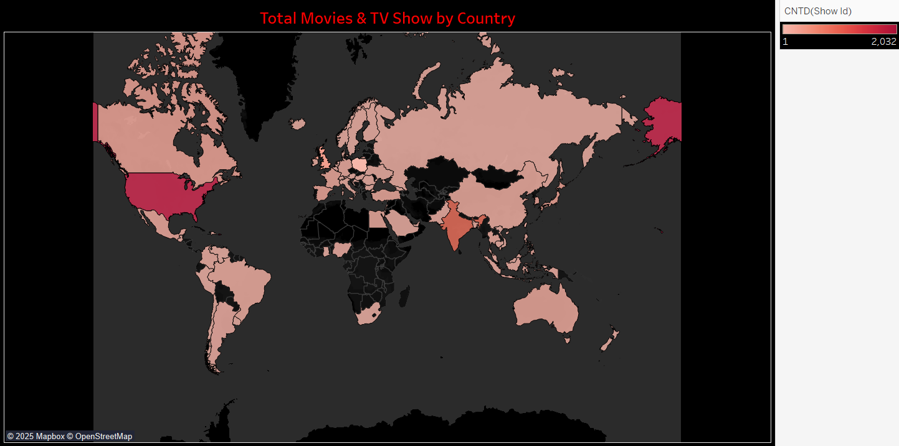

* **Most content** comes from a **few major countries** (USA, India, UK, Canada).
* **Global distribution** is very **uneven** — some regions like Africa have **very low production**.
* The map makes it **easy to compare countries** visually in **one glance**.

Movies vs TV Shows Distribution

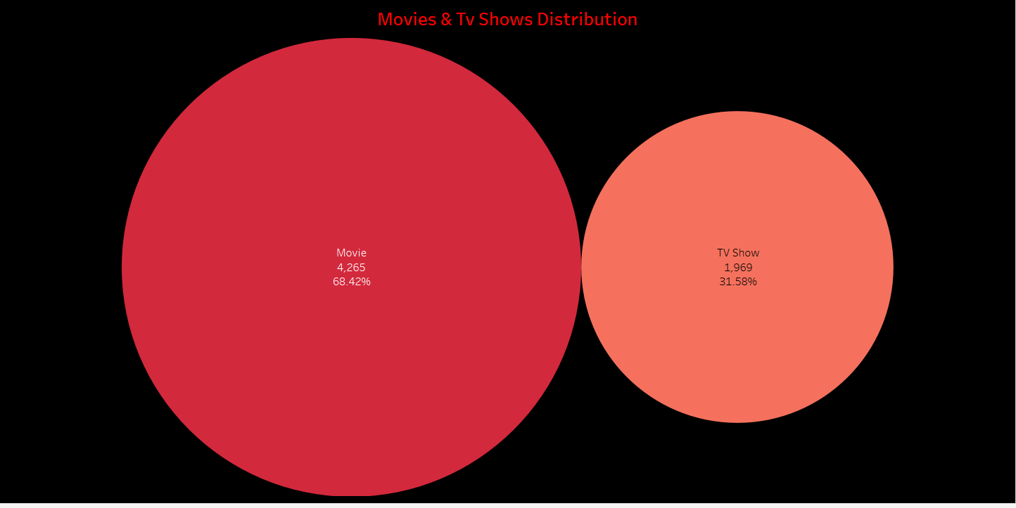

This chart shows the percentage split between Movies and TV Shows on Netflix.

* Movies are the dominant type of content.
* Useful to understand Netflix's main content strategy.

Ratings

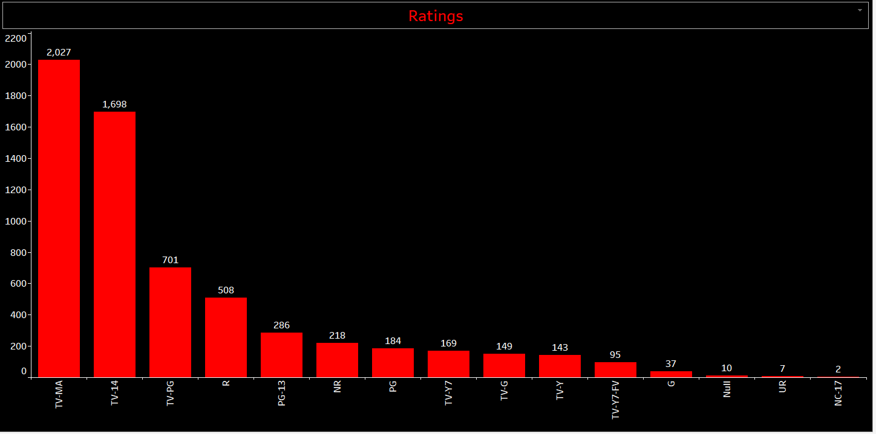

This bar chart shows how Netflix content is rated (e.g., TV-MA, PG-13, R).

* Most content is rated for mature audiences (TV-MA).
* Helps users quickly see the platform's target audience.

Top 10 Genres

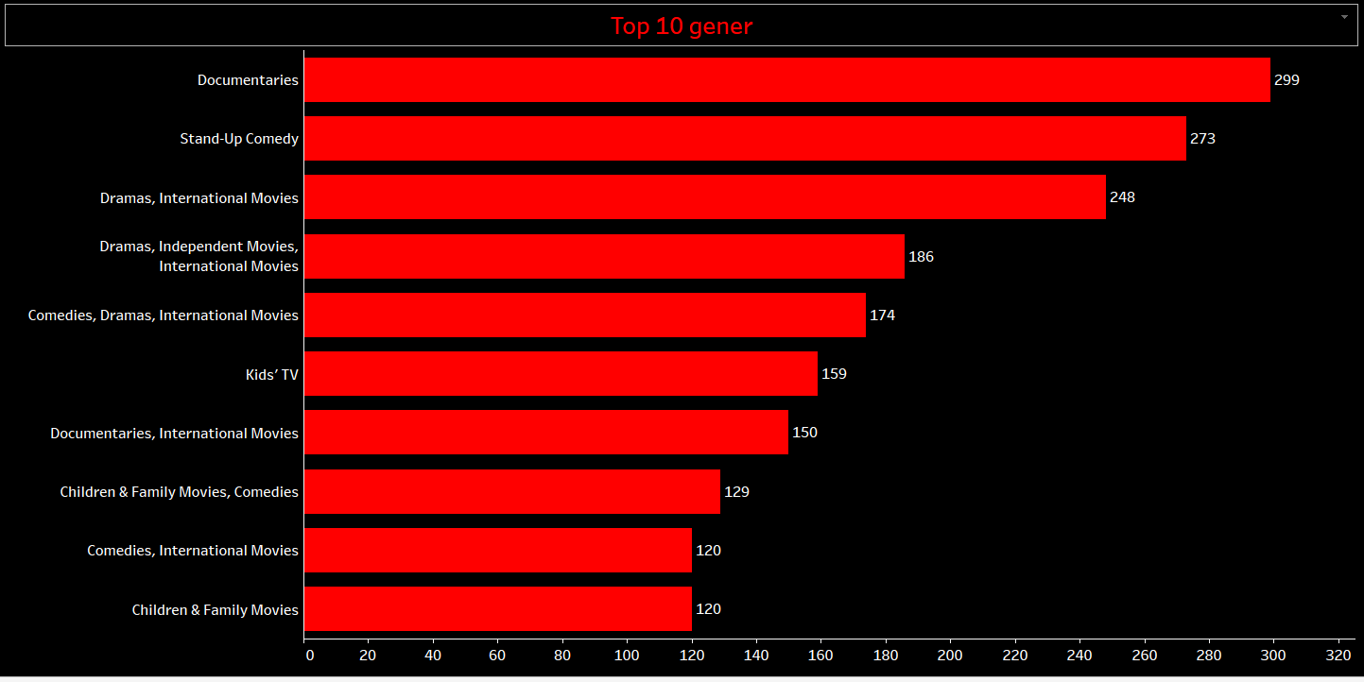

This bar chart shows the most popular genres on Netflix.

* Genres like Drama, Comedy, and Action are dominant.
* Useful for understanding content focus.

Show Description

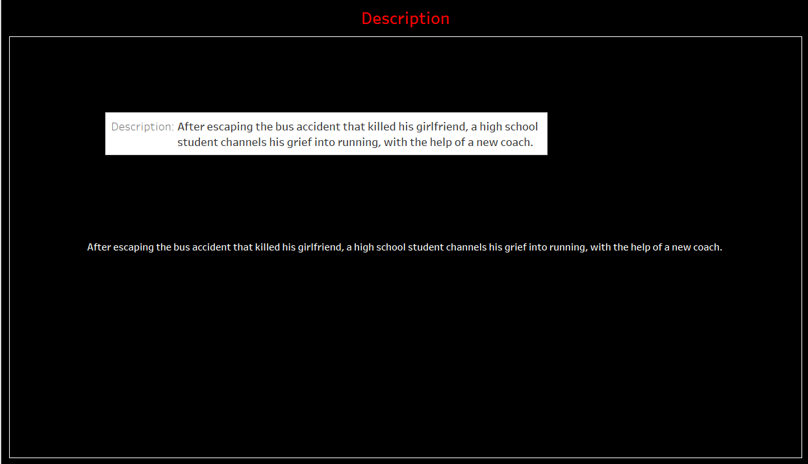

This section displays a brief description of the selected Movie or TV Show.

* Adds more detail for the user to explore titles deeply.

Full Dashboard

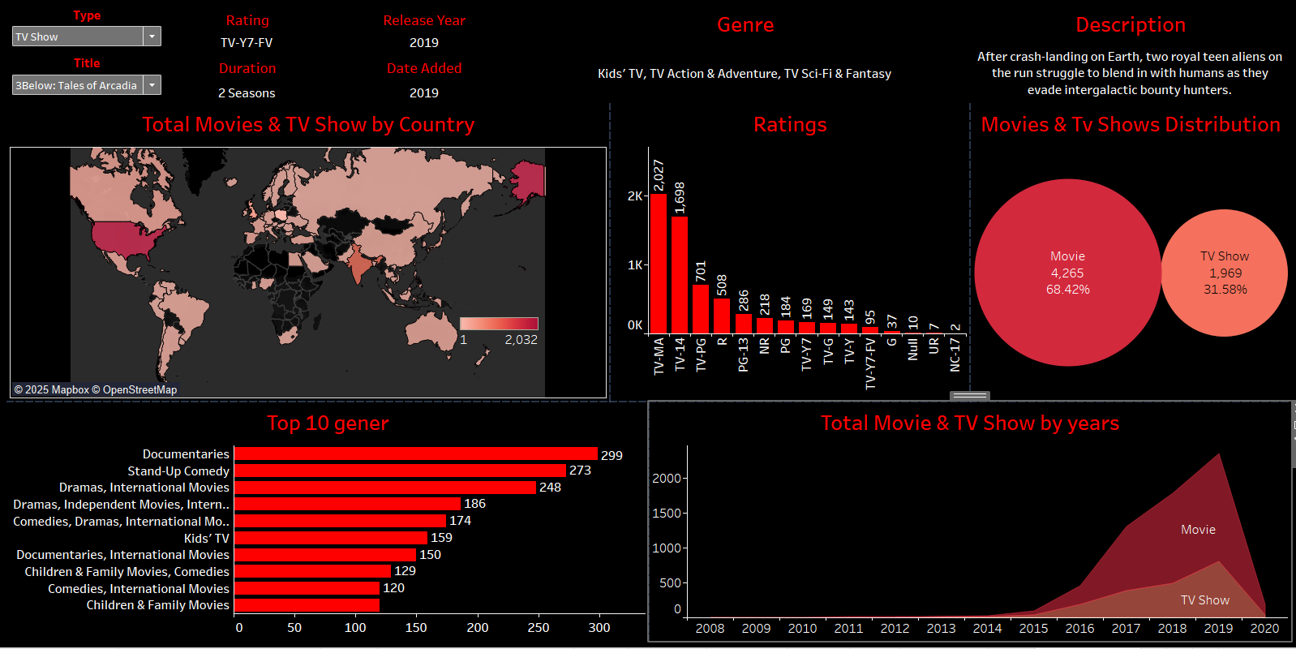

The dashboard combines all visualizations into a single interactive view.  
Users can filter by Type and Title, view content growth over time, analyze ratings, explore global distribution, and find genre preferences easily.  
The dark theme with red highlights matches Netflix’s brand style, making the dashboard look professional and attractive.

Conclusion

The Netflix Dashboard created in Tableau provides a powerful, interactive way to explore Netflix’s extensive content library.  
By analyzing key aspects such as content distribution by country, rating breakdowns, yearly growth, and genre popularity, users can gain valuable insights into Netflix’s global reach and content strategy.

Each individual visualization — from maps to bar charts — offers a different perspective, making the overall dashboard both informative and easy to navigate.  
The interactive filters further enhance user experience, allowing for customized and detailed analysis